CMPE 172

Homework #5 Apache ServiceMix

Team GreenFace

Viet Nguyen, Hoa Nguyen, Minh Ngo

1. 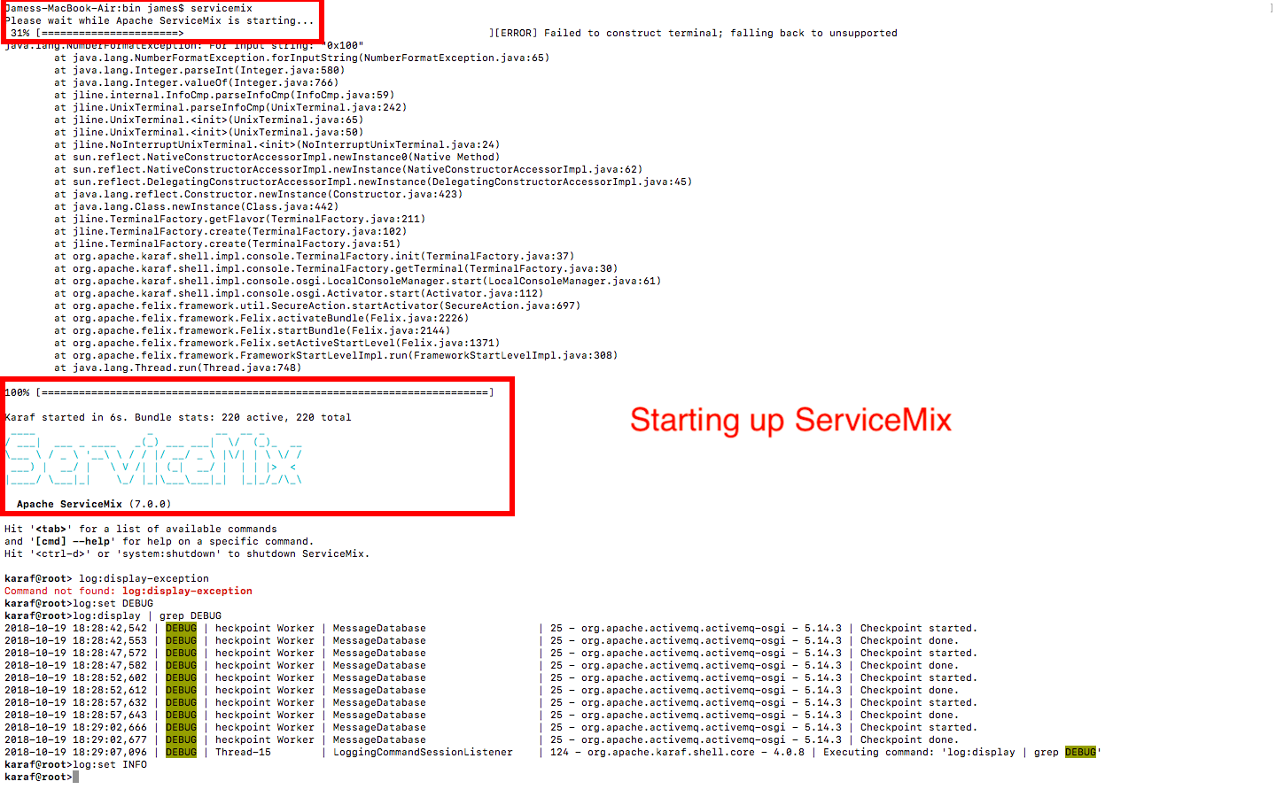Download and Setting up Apache Service Mix
2. Section 1 to 5 of the tutorial
3. Section 1 to 2

Installing and Running ServiceMix as the above picture.

1. Section 3

Running bundle:list

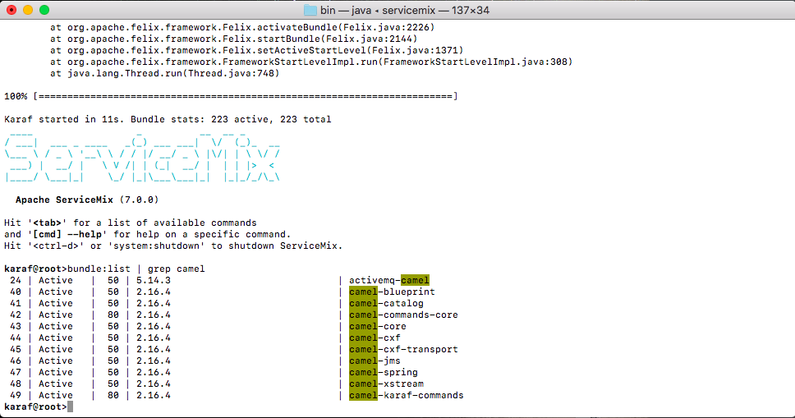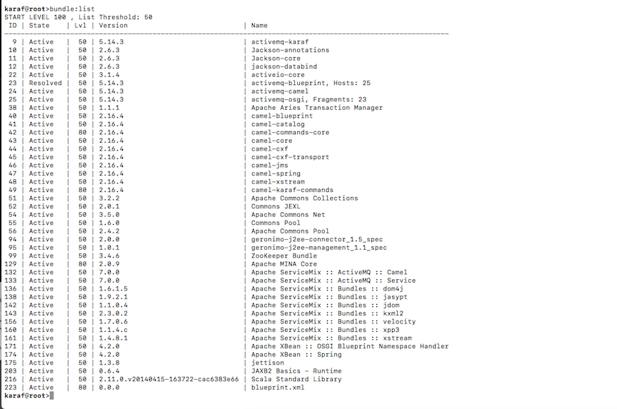Result of command: bundle:list | grep camel

Log command

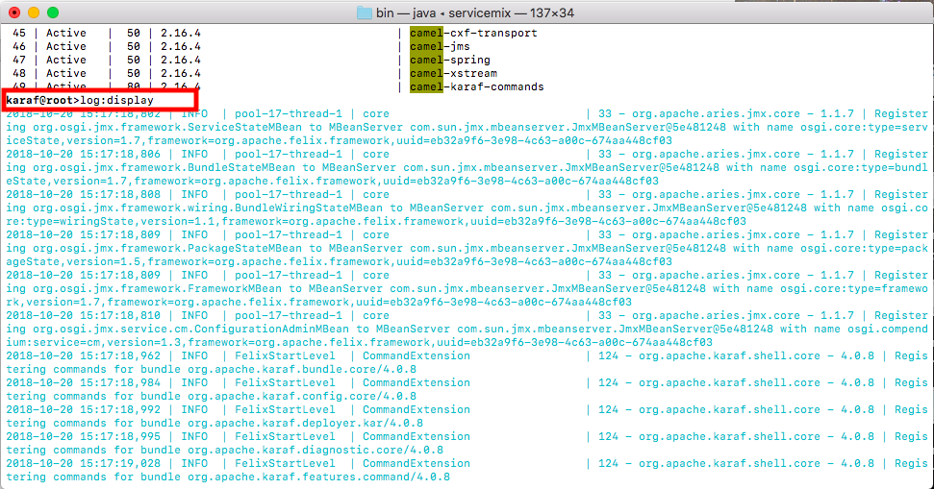

Log:debug and set debug commands

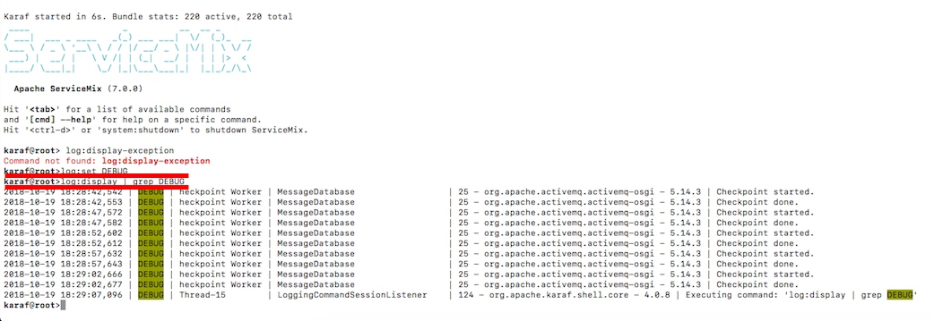

1. Section 4

Create the blueprint.xml as instructed from the tutorial and put in the deploy folder

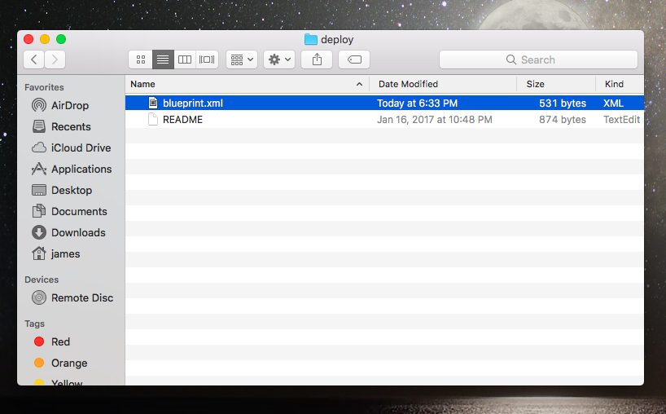

The file was moved.

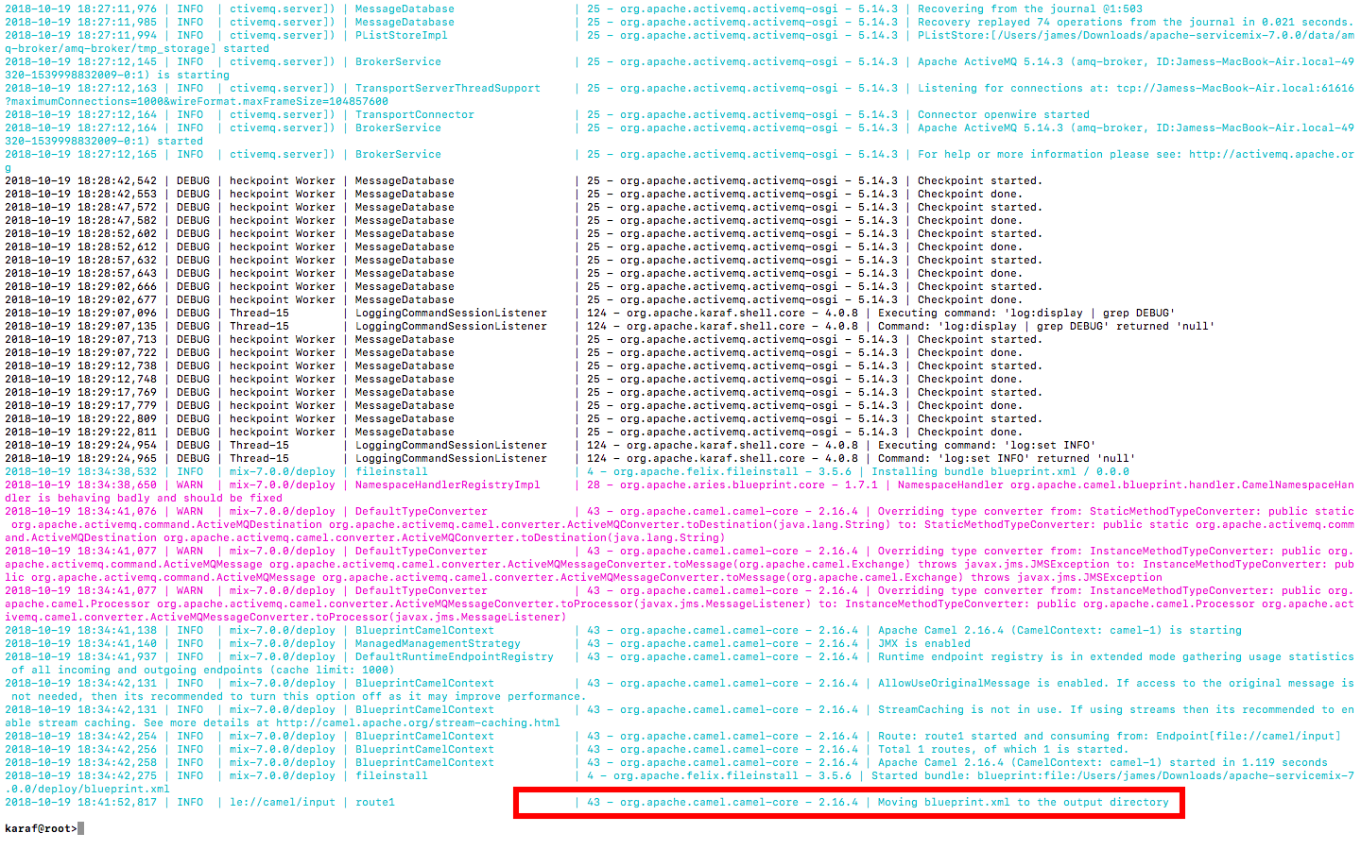

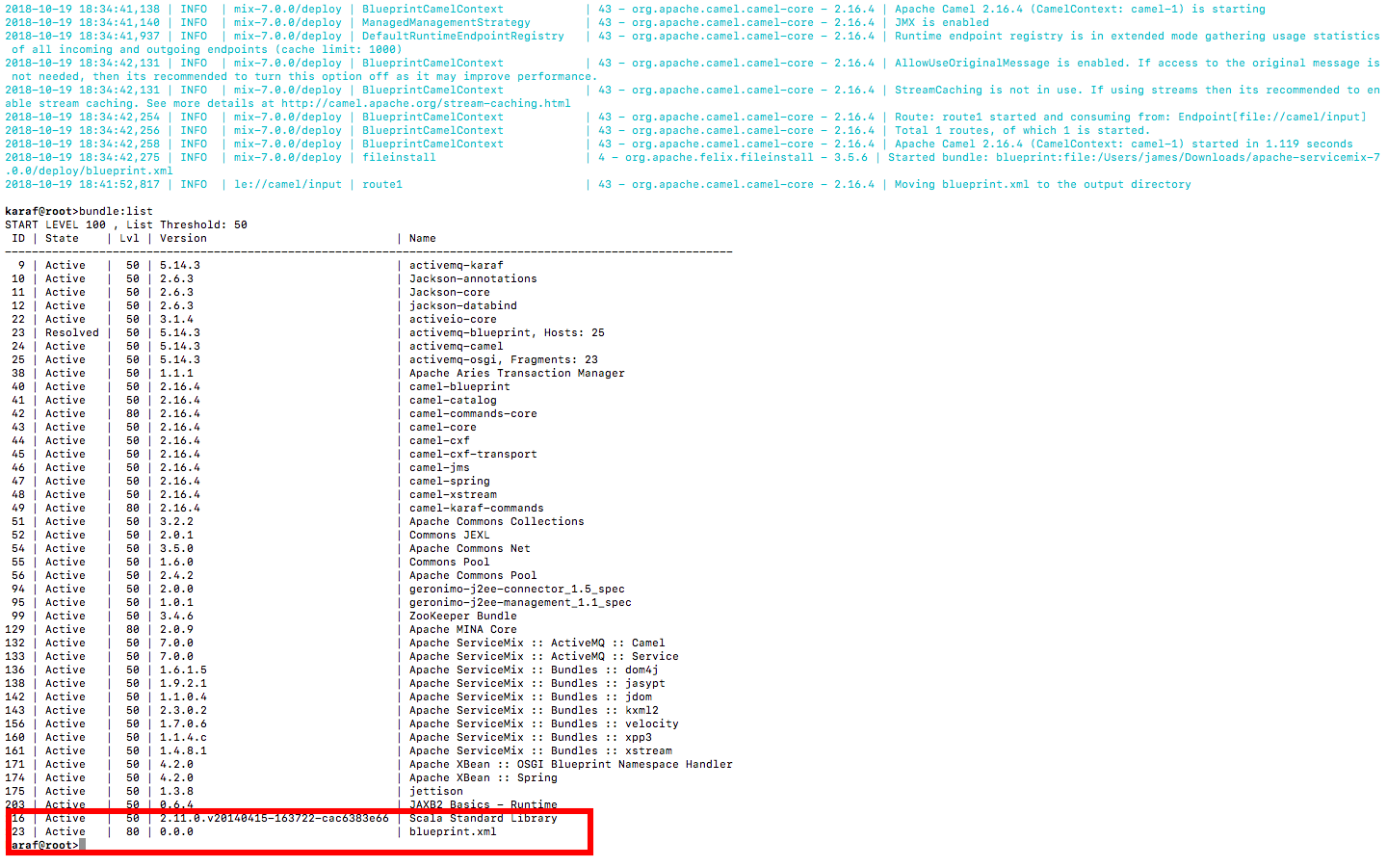Stop the bundle

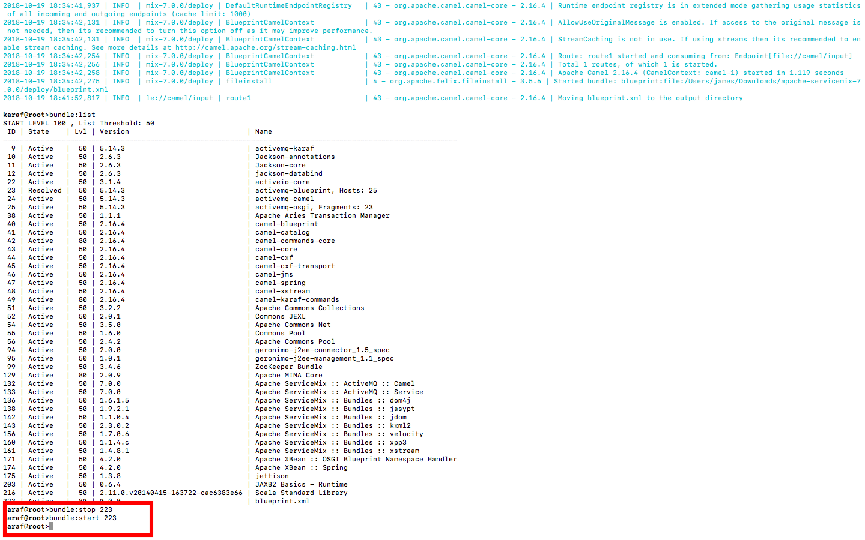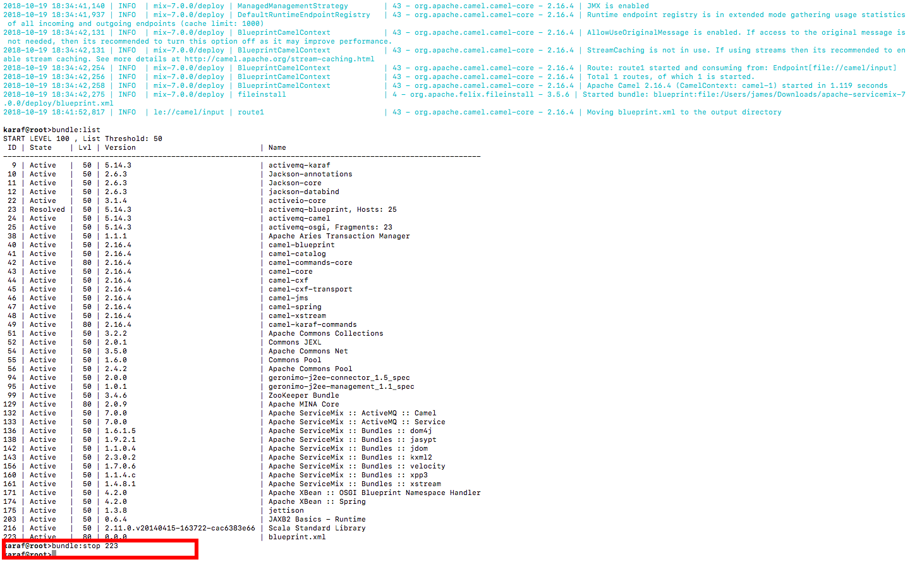

1. Section 5

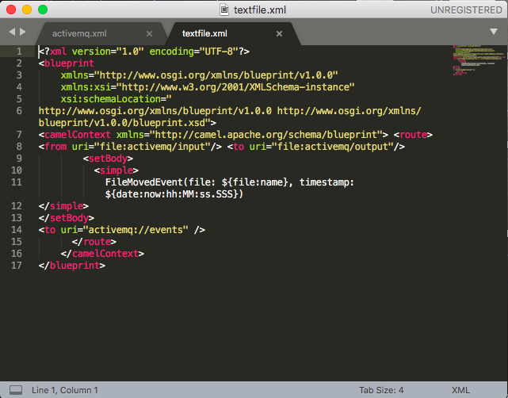Create the xml file

Deploy it and check for result

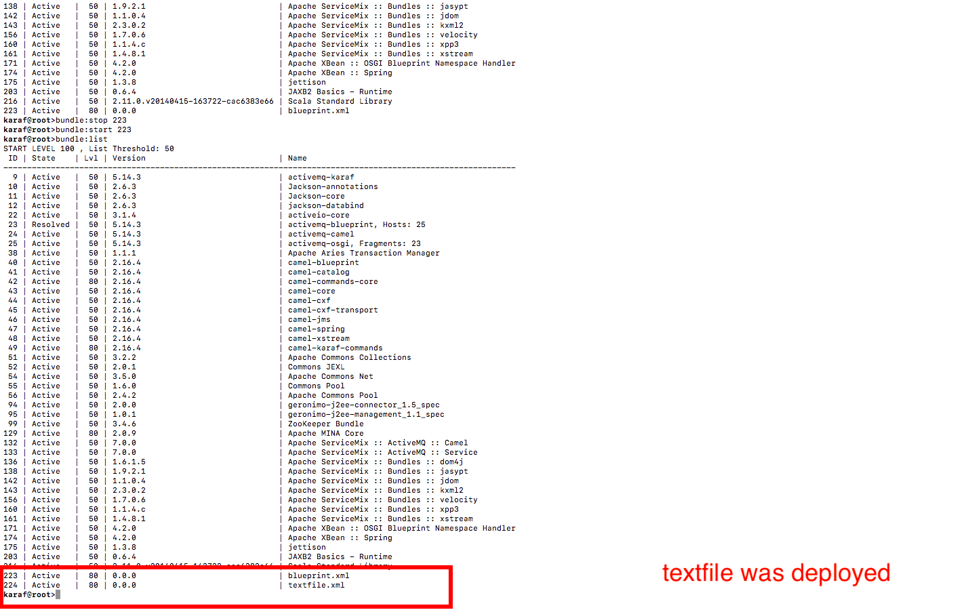Create the second textfile

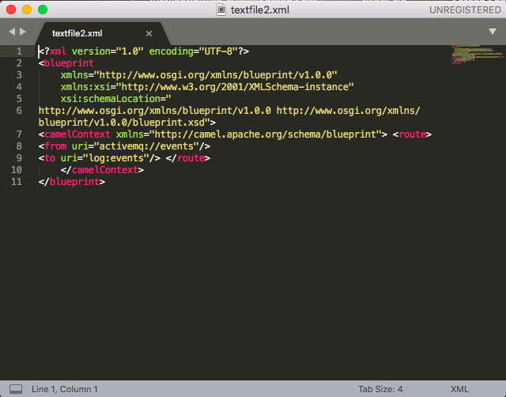

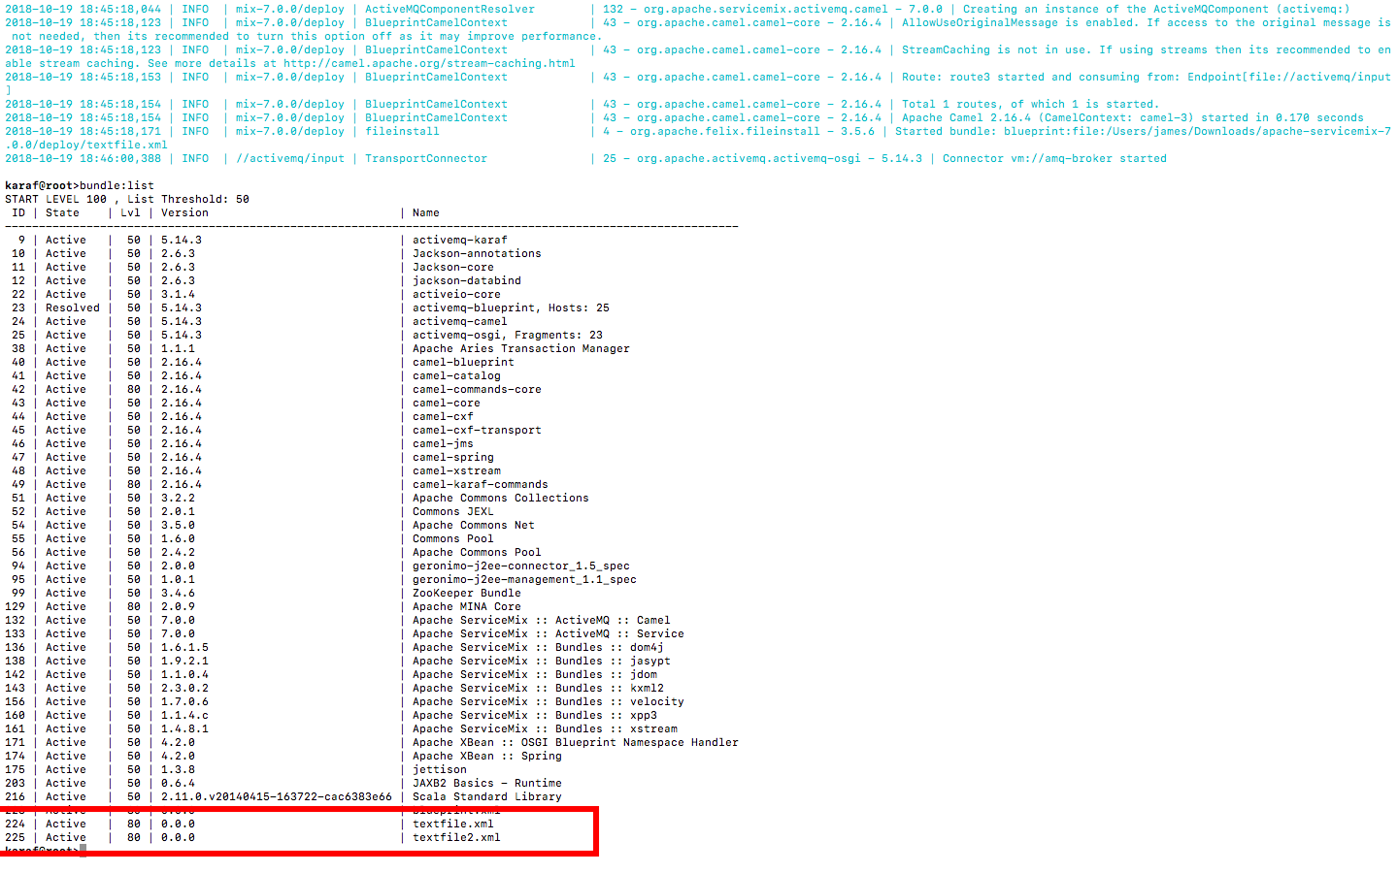Check the content of message being sent

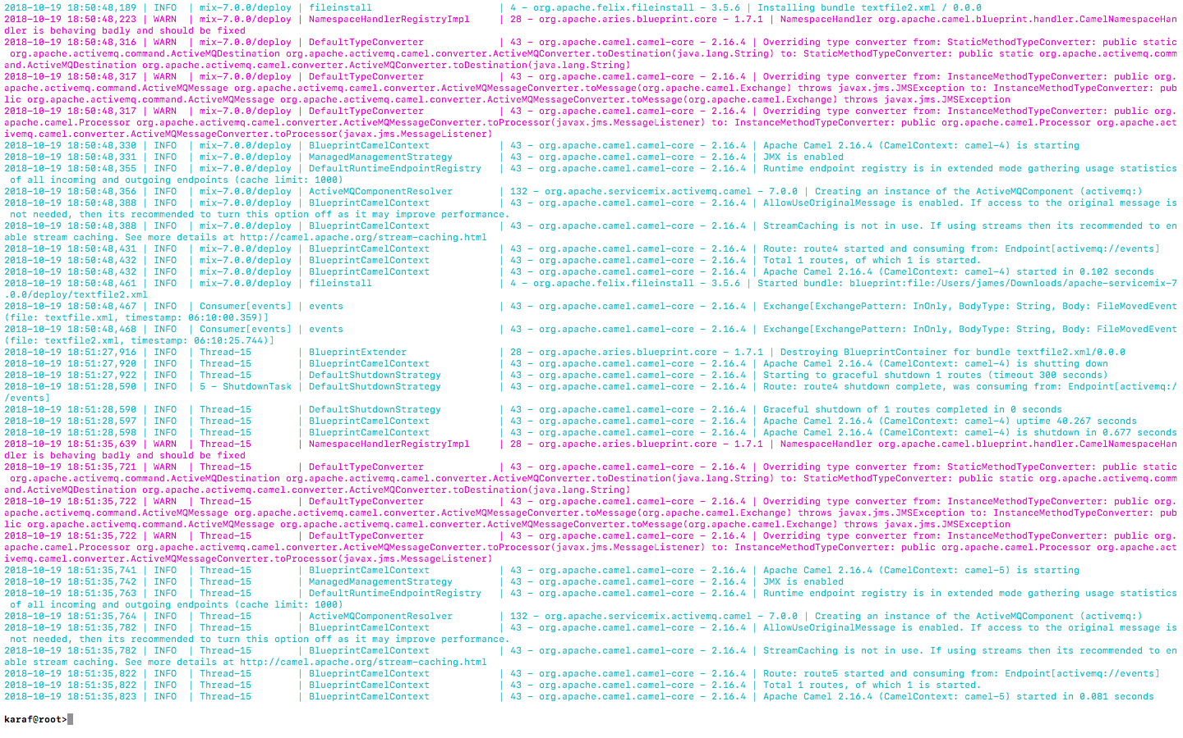

1. Creating JMS application and deploy it.
2. 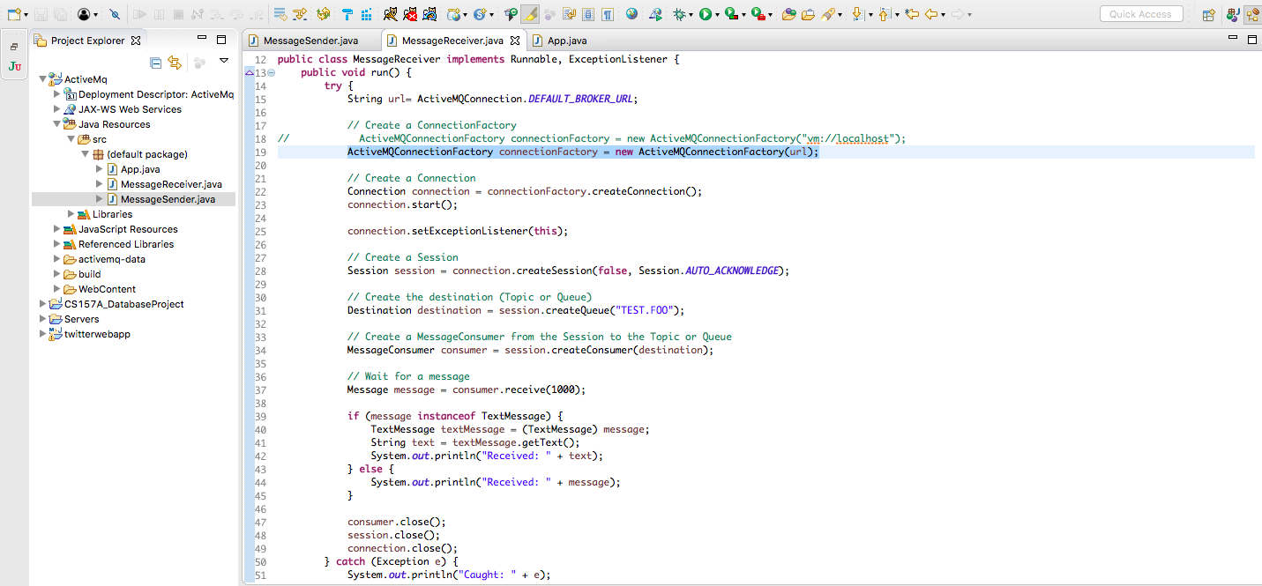Create the java files inside Eclipse
3. 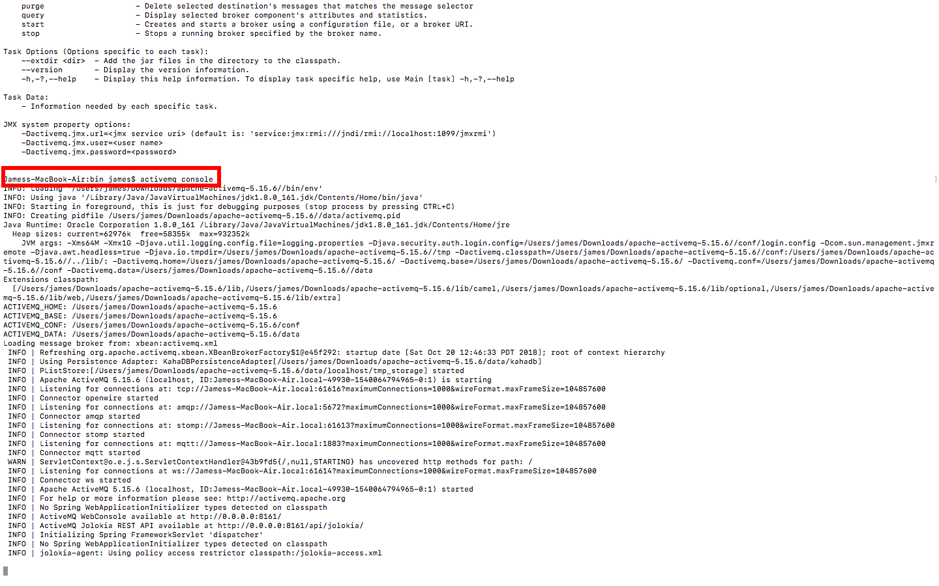Install and start ActiveMQ

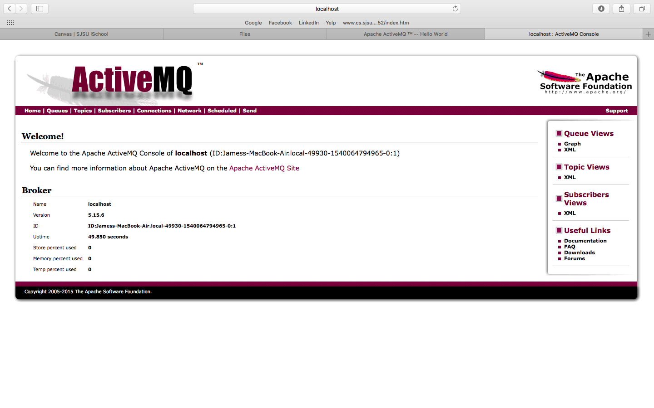Start up the ActiveMQ local server

Run the MessageSender and check the MessageQueue

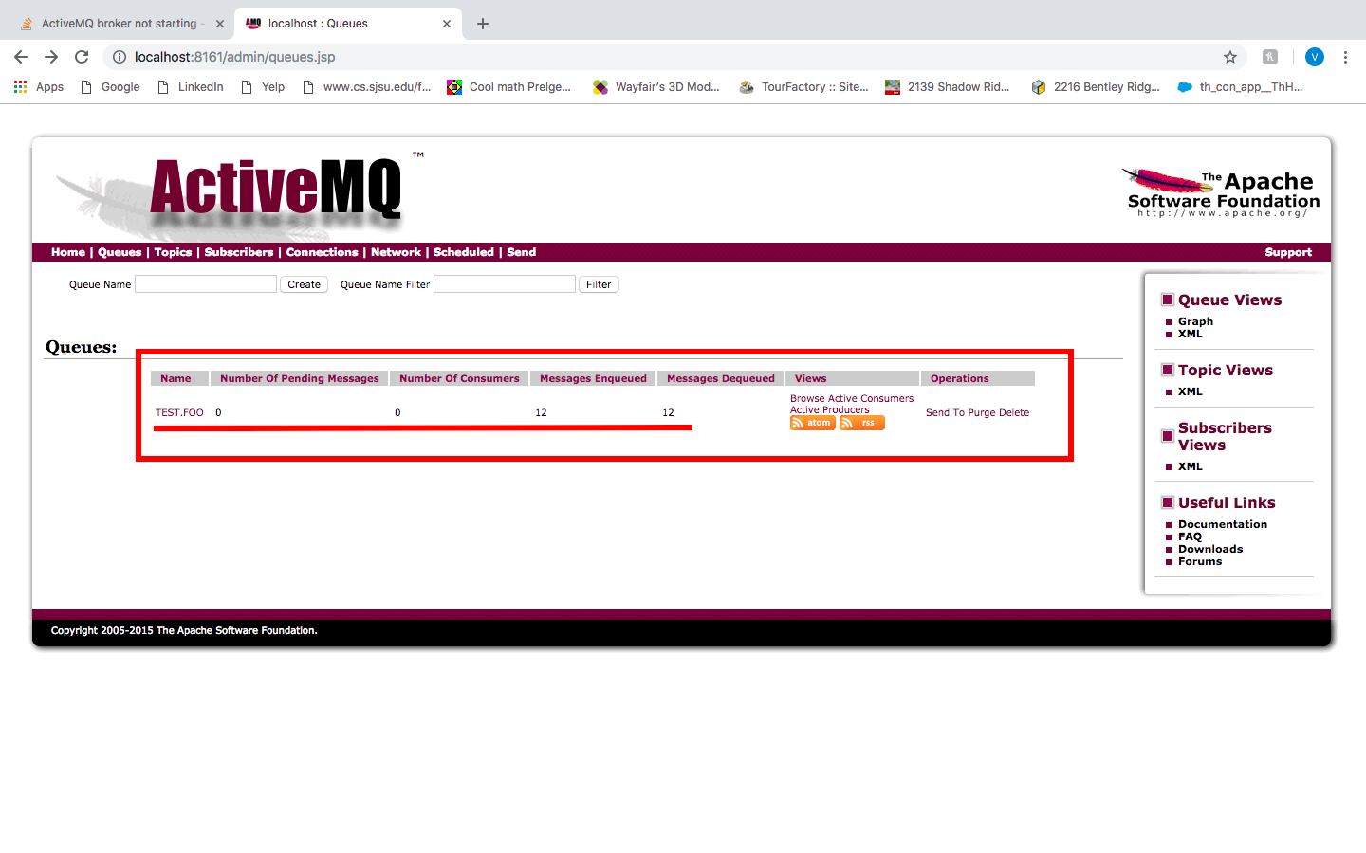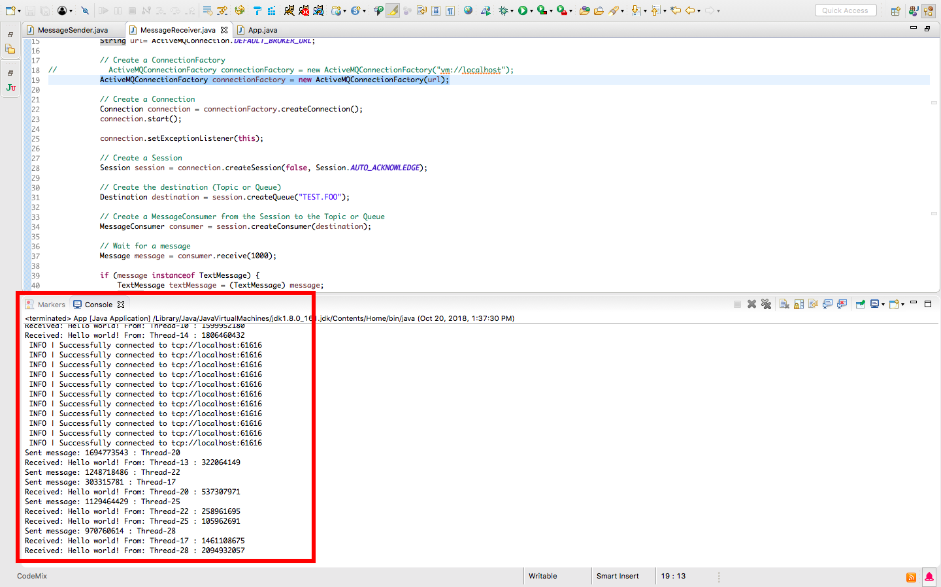As showed above, multiple senders and receivers were successfully created and run.